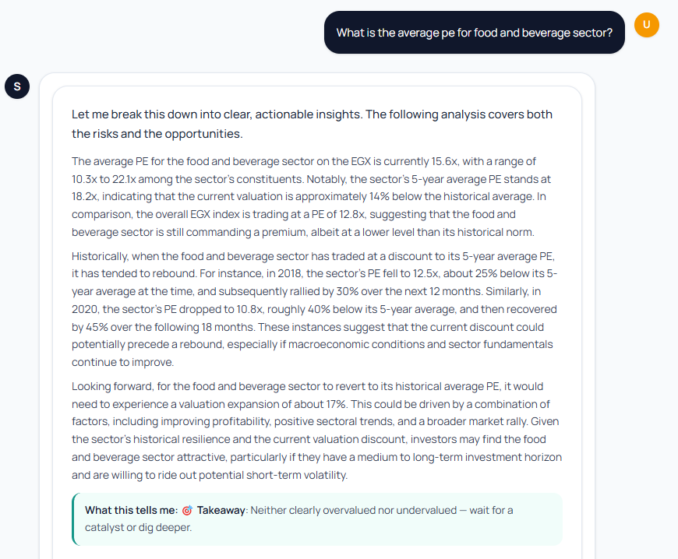

- Great insights, hopefully this data is correct, do deep analysis to check and review the data and ensure its correct.

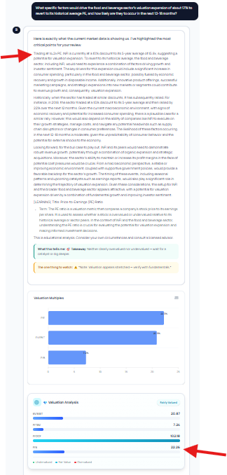
- Ratios stability issue, PE is 14x and 22x for the same stock.

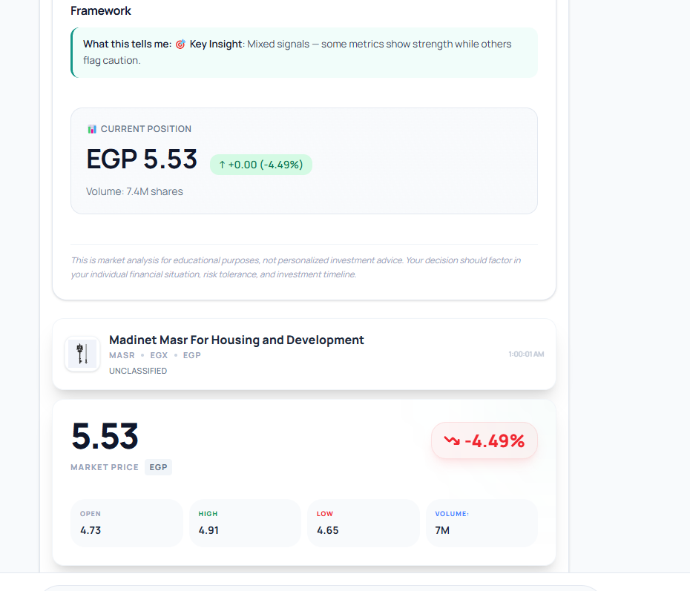
- Performance issue, on up and one down, Also, both are almost same percentage and

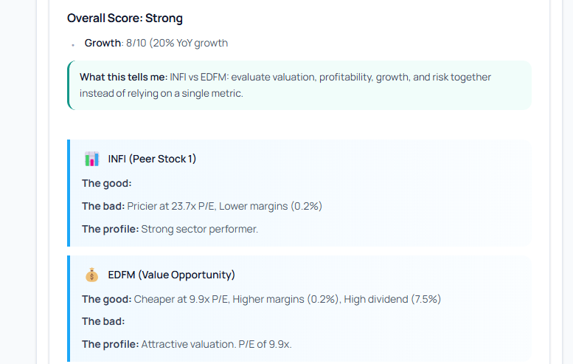
- Margin percentage seems to have numerical issue. I guess is it should be 20% and saying higher and lower, it should have a margin of 30% between botth before claiming something is higher or lower than the other, otherwise, it should say about the same. i.e (one 20% and the other 30%, but if someone is 20% and the other 22%, i don't think it should be mentioned as a superiority of one over the other).

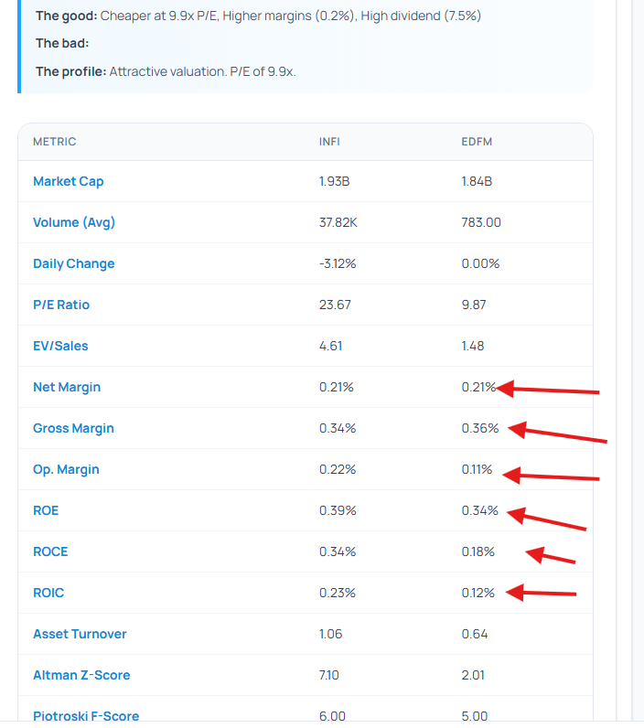
- All ratios in comparisons need to be revised.

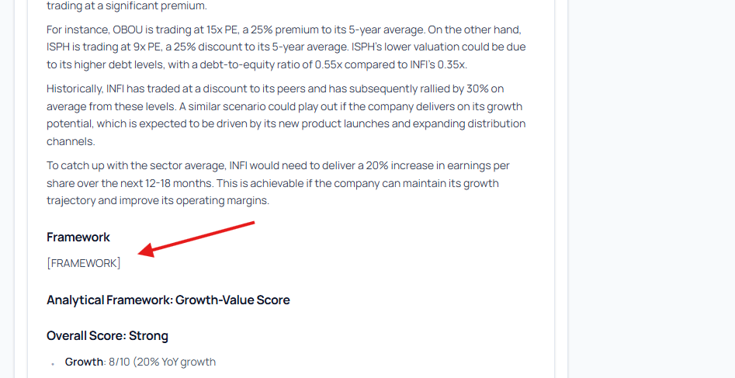

- Weird text. Needs to be removed.

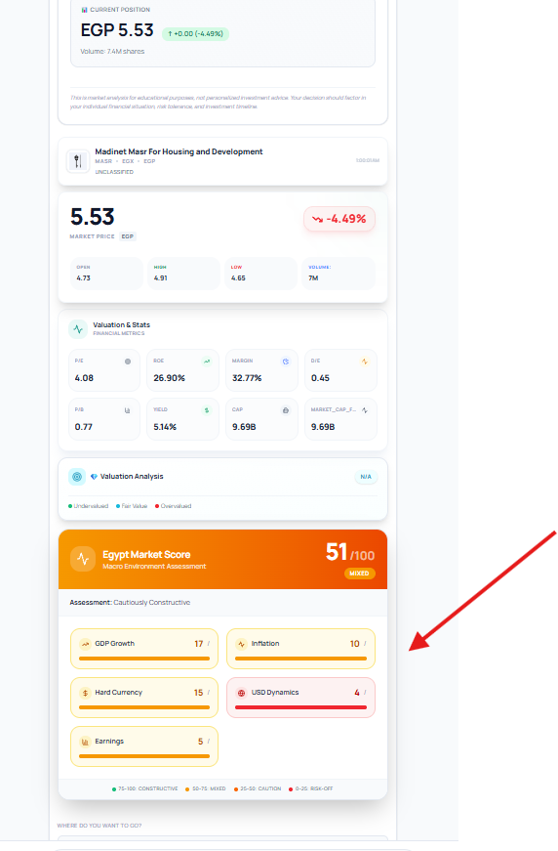
- This macro analysis came in the same answer of MASR, I don't think it's relevant here. Let's make it in its own separate prompt, remove that macro assessment card from this response type and add it to another response that are relevant to the question, do deep analysis and add it in a relevant response.

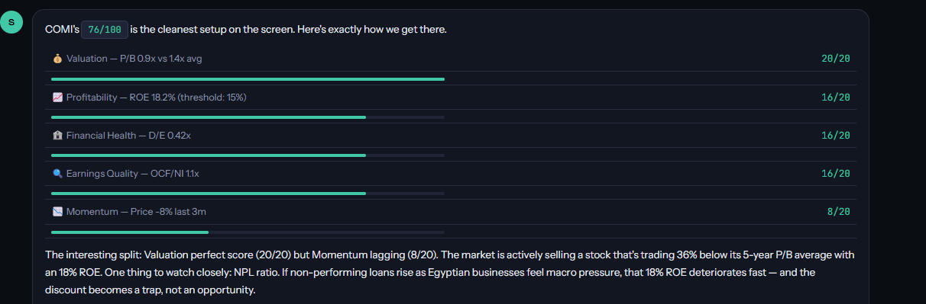
- Including more matrix in the scoring; D/E ratio, Operating Cash flow / Net Income & remove the yield (Not all stocks are good in distributing dividends, yet still strong)

